**Group Members:** Reema Parakkal(132), Aayushi Pawar(143), Nikita Pawar(144)

**Subject Name:** Information Security

**IA 1**

**VERACRYPT-Disk Encrytion**

**Introduction**

Veracrypt is an open-source disk encryption software designed to provide users with a high level of security for their data. Veracrypt is available for various operating systems, including Windows, macOS, and Linux. The primary purpose of Veracrypt is to encrypt data stored on disks, partitions, or portable storage devices to protect it from unauthorized access. It achieves this by creating encrypted containers or volumes where files can be securely stored. These containers act as virtual encrypted disks, ensuring that sensitive information remains inaccessible to anyone without the correct decryption key.

In cybersecurity, VERACYPT is used for

* Veracrypt supports multiple encryption algorithms, including Advanced Encryption Standard (AES), Serpent, and Twofish, allowing users to choose the level of security that aligns with their specific requirements and preferences.
* Beyond basic encryption functionalities, Veracrypt offers advanced features such as hidden volumes, system encryption, and plausible deniability. Hidden volumes enable users to conceal sensitive data within encrypted containers, providing an additional layer of security by making it indistinguishable from regular data.
* System encryption capability extends Veracrypt's utility to encrypting entire system partitions, ensuring comprehensive protection for the operating system and user data against unauthorized access.

**Features/Characteristics:**

**1. Creation of Encrypted File Container:** Veracrypt allows users to create encrypted file containers of customizable size using various encryption algorithms such as AES, Serpent, and Twofish. These containers act as virtual encrypted disks where files can be securely stored.

**2. Mounting the Veracrypt Container:** Once a container is created, Veracrypt enables users to mount it as a virtual drive on their system. This mounted volume behaves like any other drive, allowing users to access, modify, and save files securely within the encrypted container.

**3. Creation of Non-System Partitions**: Veracrypt extends its encryption capabilities beyond file containers to non-system partitions such as USB drives. Users can encrypt entire partitions, ensuring data remains protected even when transferred between devices.

**4. Creating New Hidden Volumes:** Veracrypt offers the functionality to create hidden volumes within existing encrypted containers. These hidden volumes are indistinguishable from the outer volume, providing an additional layer of security by concealing sensitive data within the same container.

**5. Outer and Hidden Volume Creation and Verification:** Veracrypt allows users to create both outer and hidden volumes within a single container. The outer volume contains legitimate data, while the hidden volume remains concealed. Veracrypt ensures the integrity of both volumes during creation and provides mechanisms to verify their authenticity.

**6. Encrypting Windows System Partition:** Veracrypt supports encrypting the Windows system partition, providing full disk encryption to protect the entire operating system and its data. This feature enhances the security of sensitive system files and user data against unauthorized access.

**7. Creating a Veracrypt Rescue Disk:** To ensure data recovery in case of emergencies, Veracrypt enables users to create a rescue disk containing essential decryption keys and tools. This disk facilitates the recovery of encrypted volumes in situations such as system failures or forgotten passwords.

**8. System Encryption Pretest:** Before initiating system encryption, Veracrypt performs a pretest to assess system compatibility and ensure a smooth encryption process. This pretest helps identify any potential issues that may arise during encryption, allowing users to address them beforehand.

**9. Encrypting Folder with Plausible Deniability:** Veracrypt offers the ability to encrypt folders with plausible deniability by using two different passwords. This feature allows users to create encrypted volumes where the existence of hidden data remains deniable, even if the outer volume is compromised.

**Methodology:**

**Installation setup:**

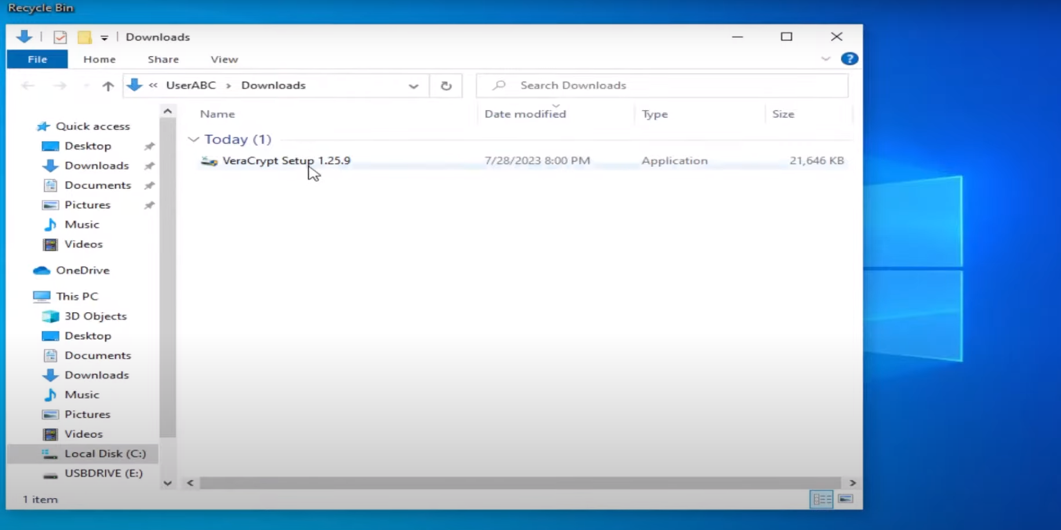

**Create an encrypted file container:**

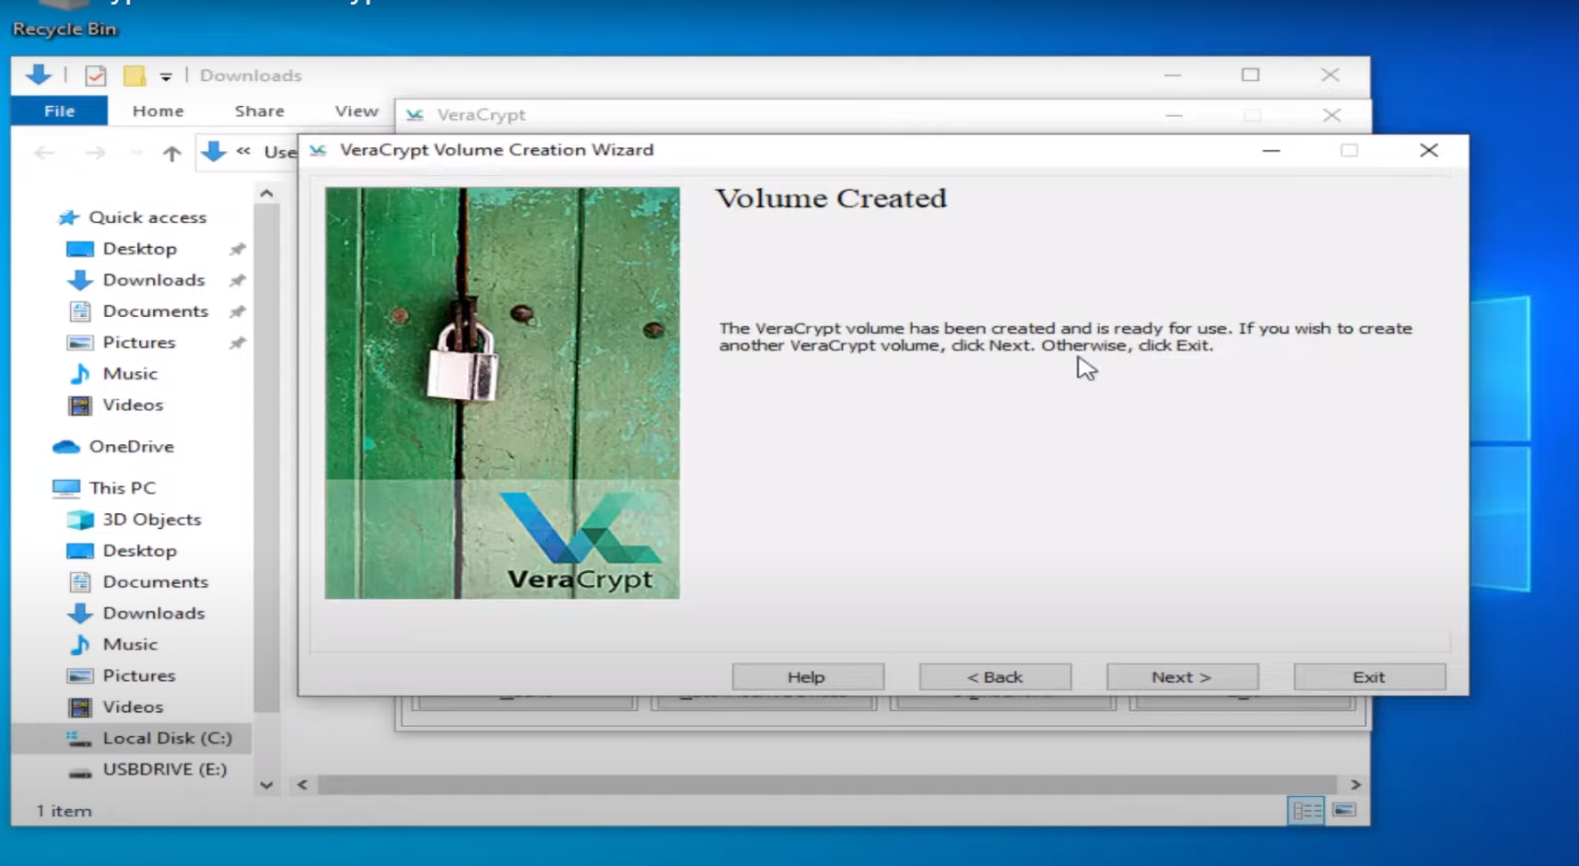

**Mounting Veracrypt container:**

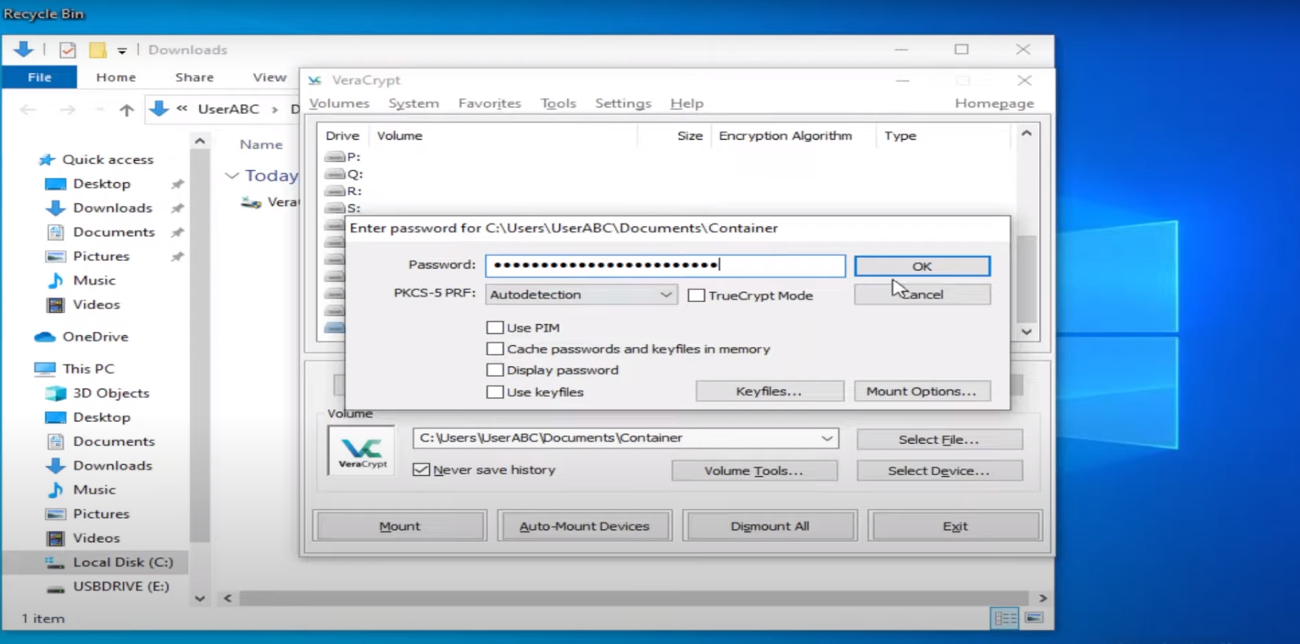

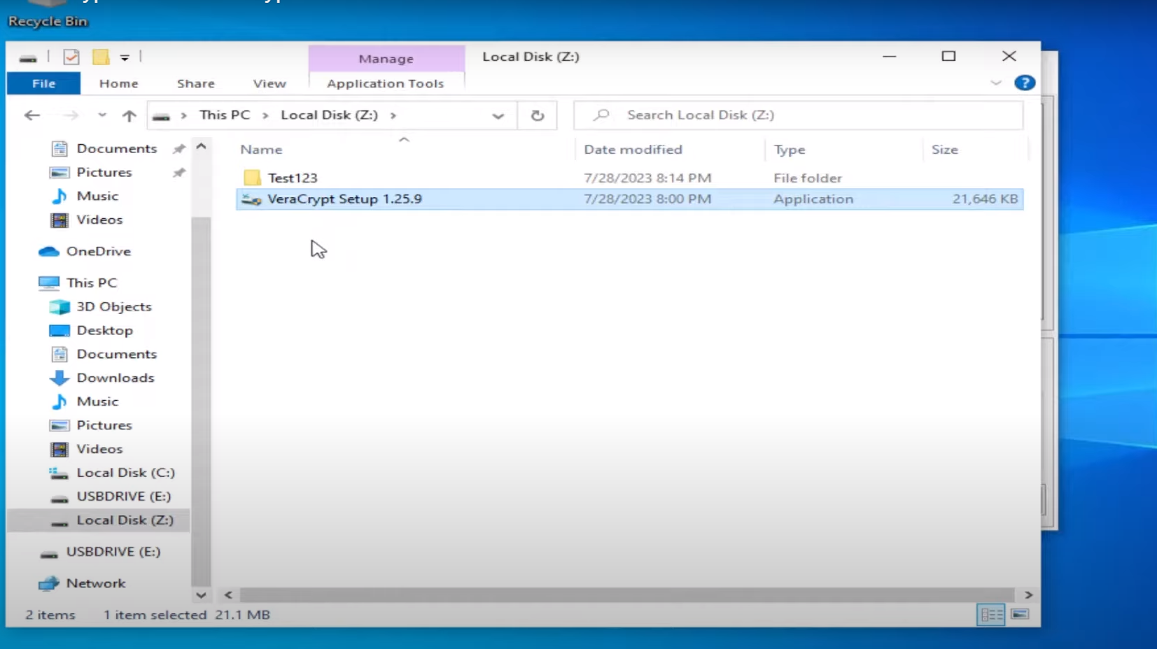

**Creating a Non system Partition(USB drive):**

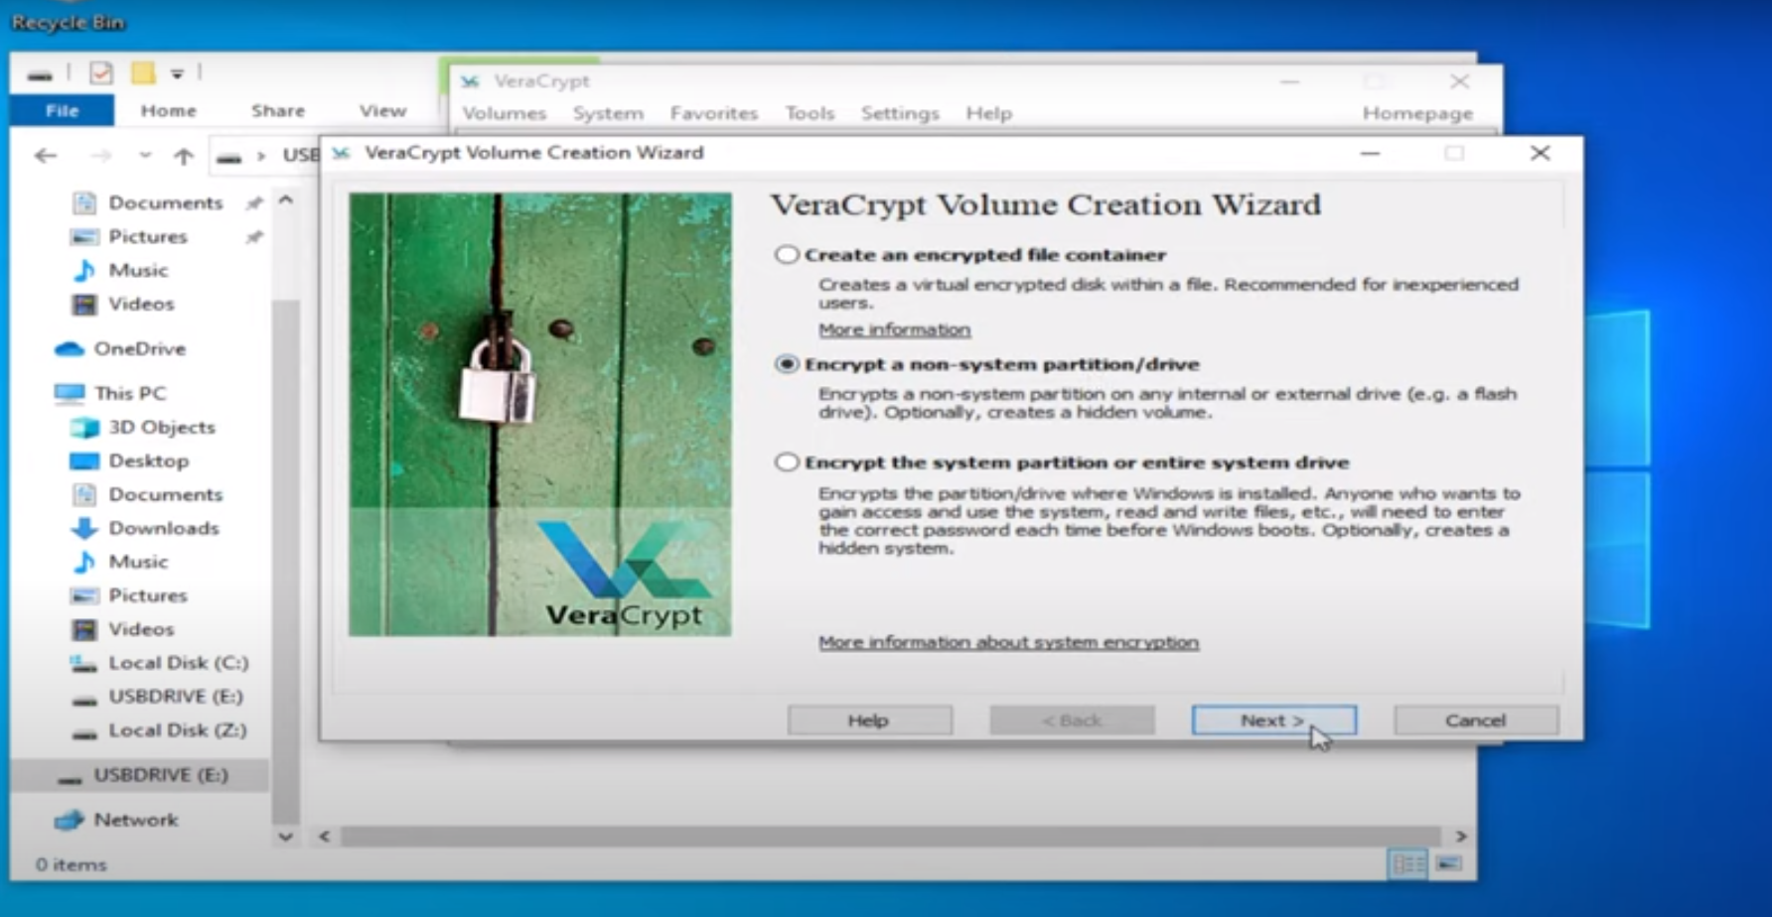

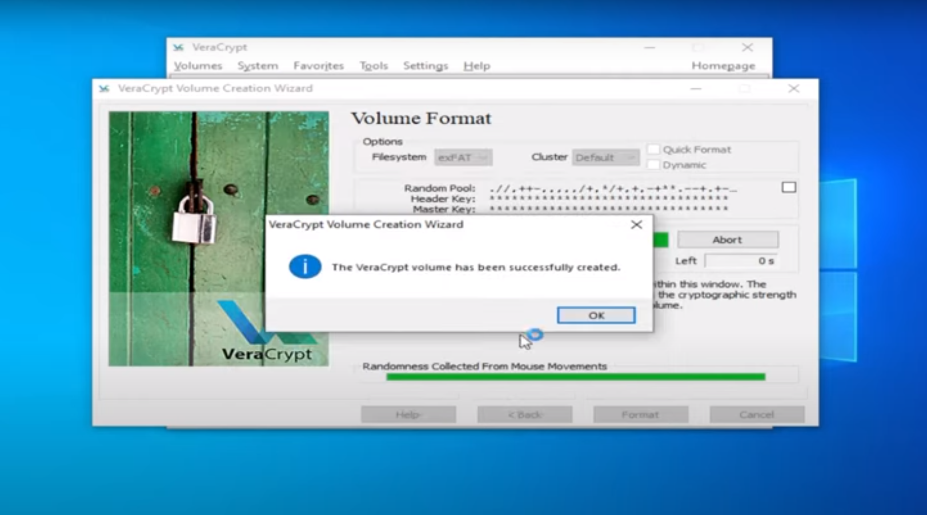

Mounting a Non system Partition:

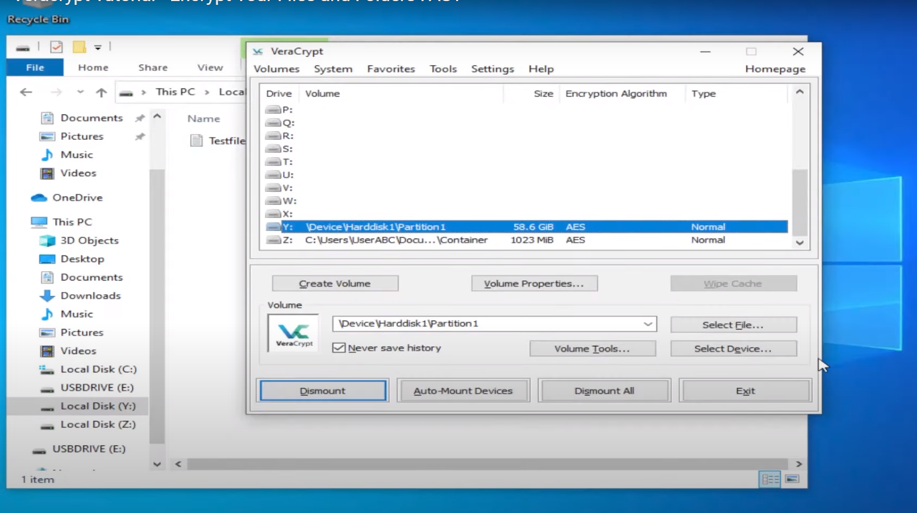

**Creating New Hidden Volume-**

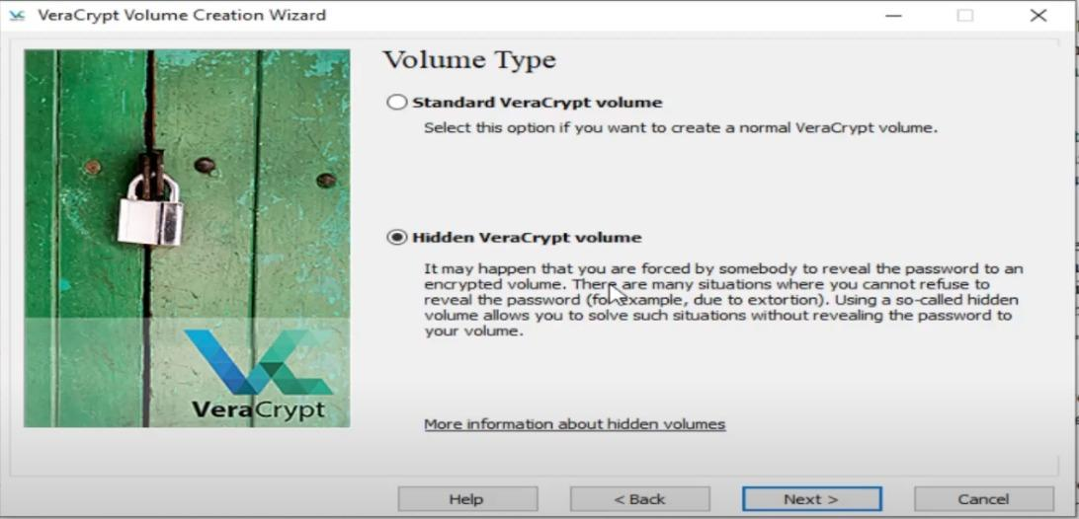

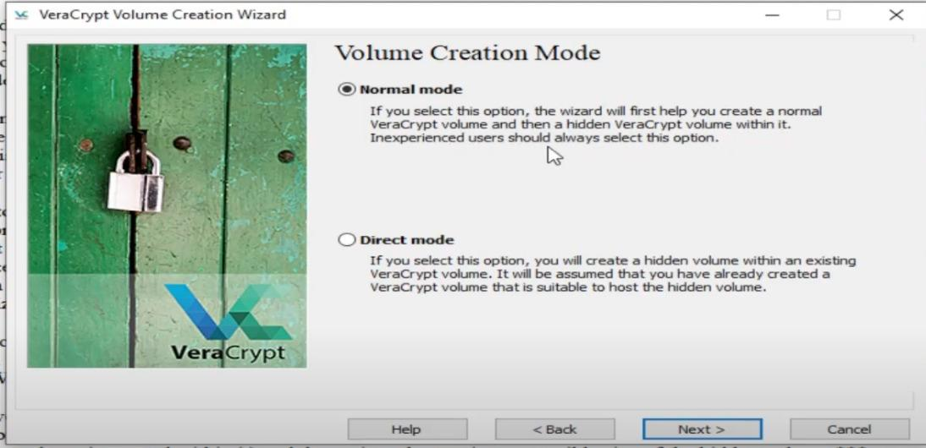

**Outer Volume Creation-**

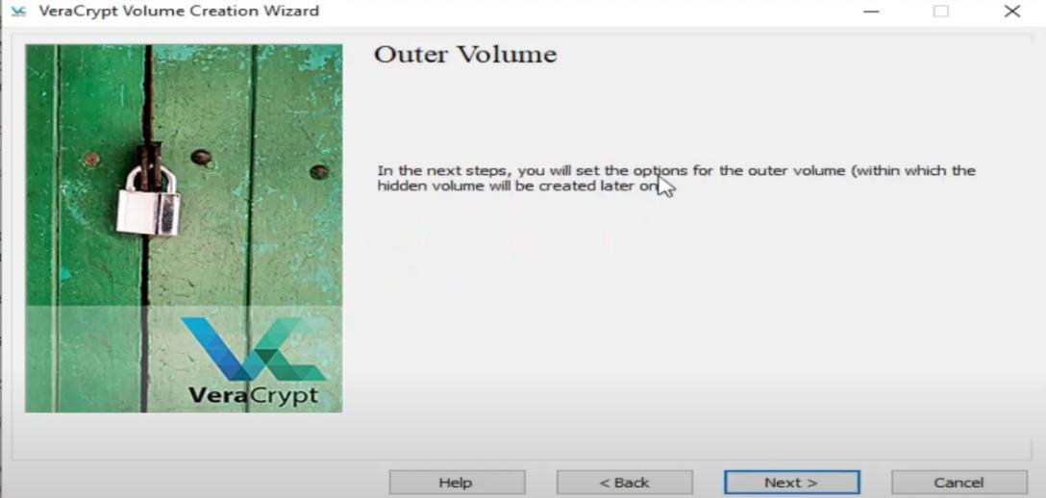

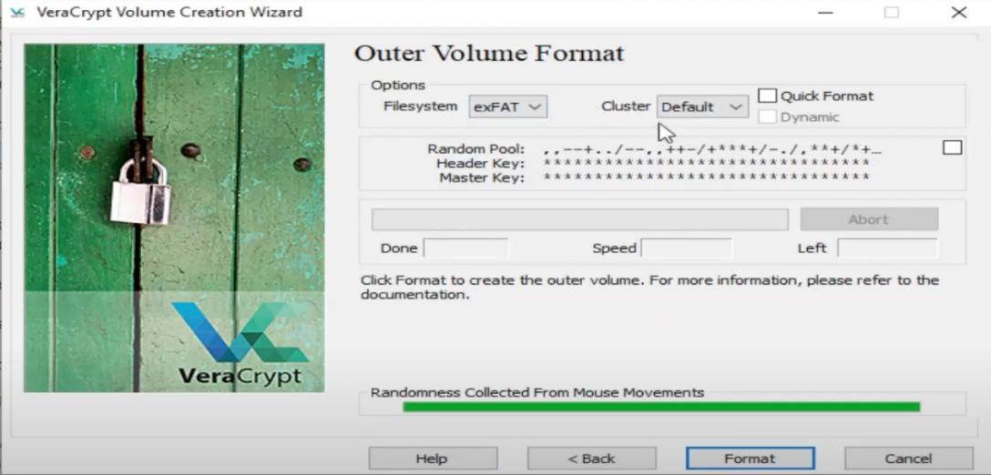

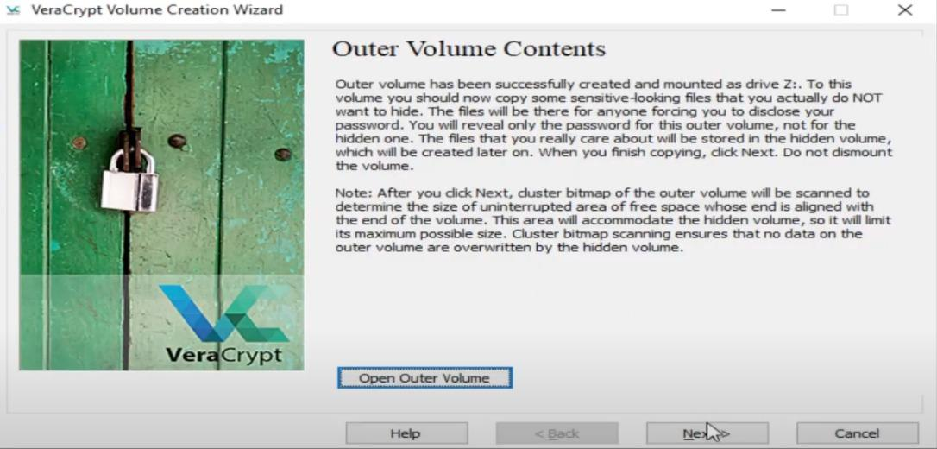

**Hidden Volume Creation**

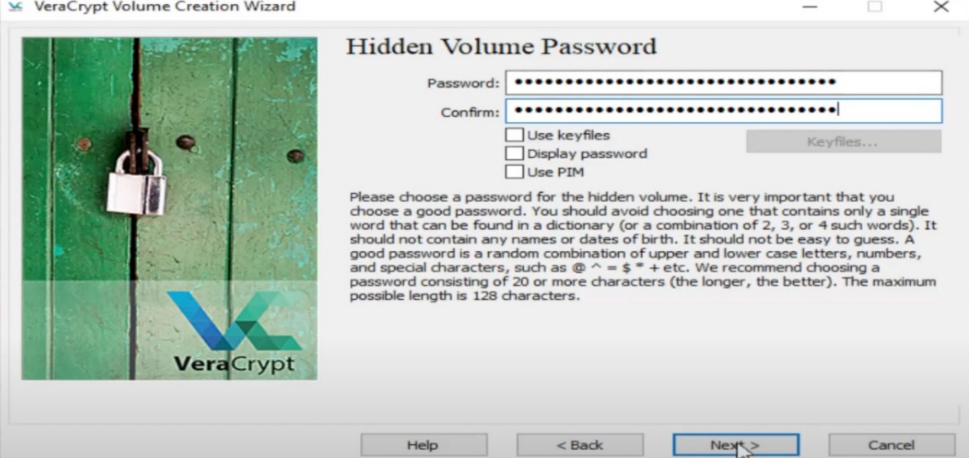

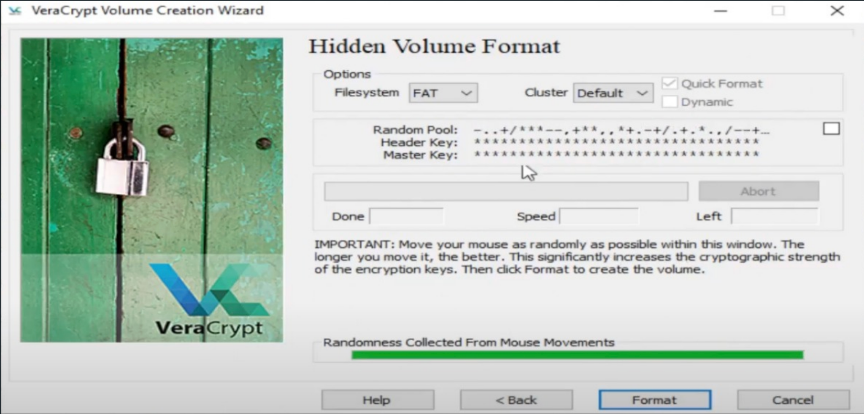

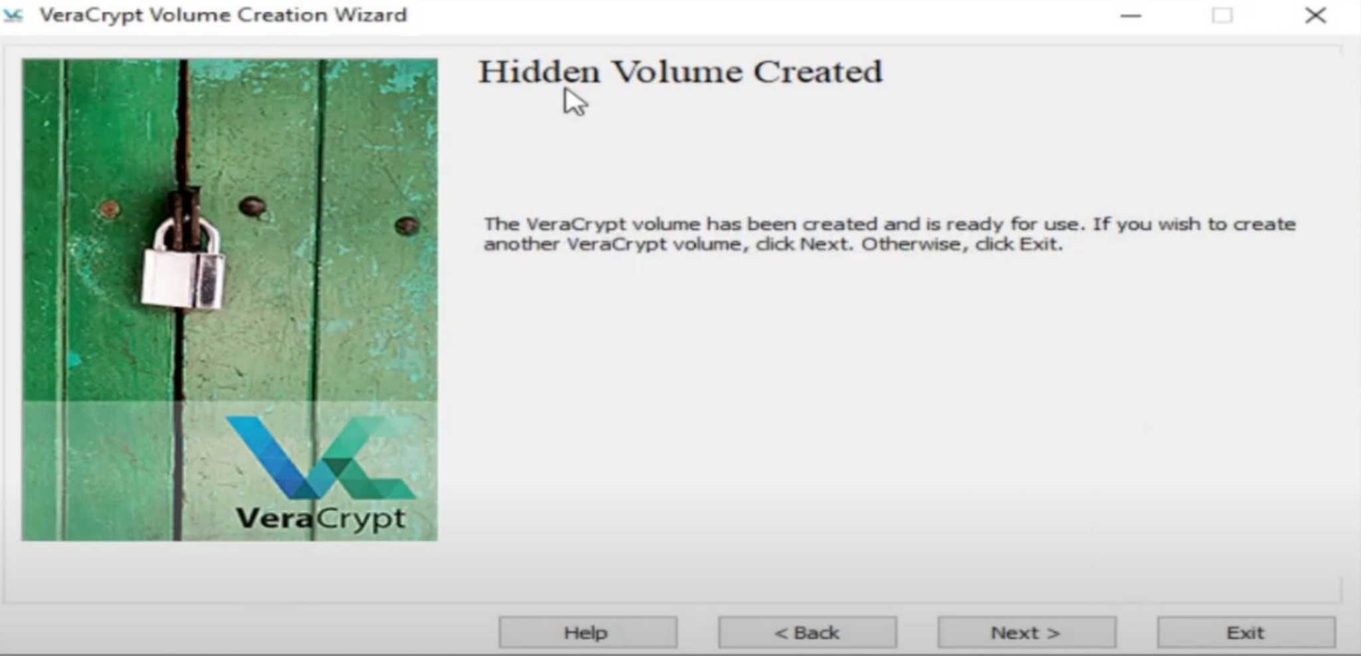

**Outer Volume and Hidden Volume Verification :**

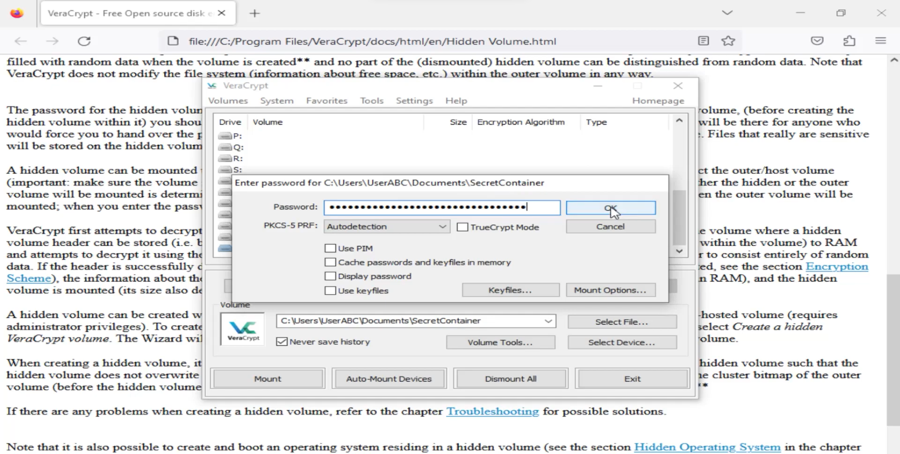

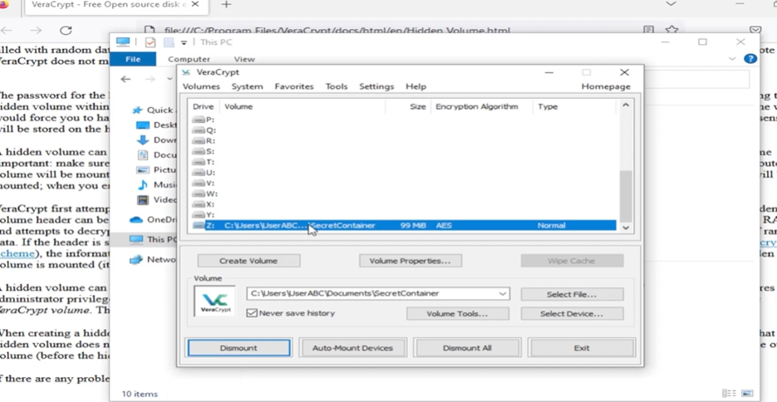

**Encrypt windows (System Partition):**

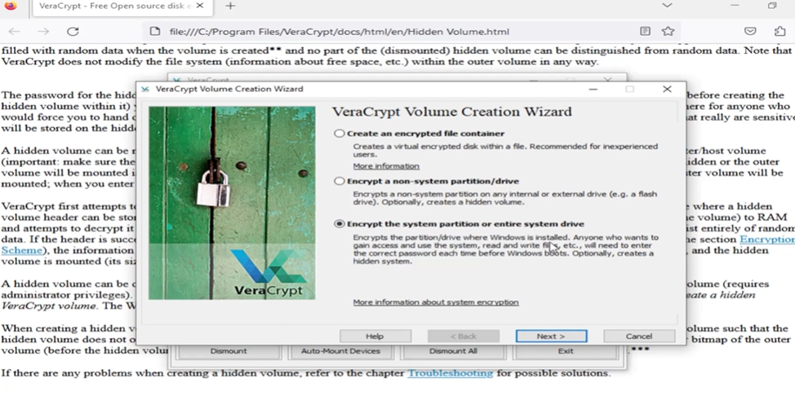

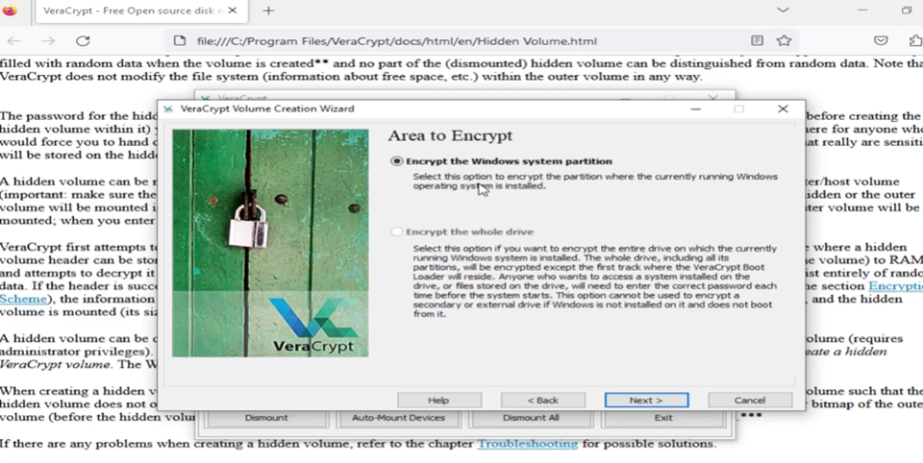

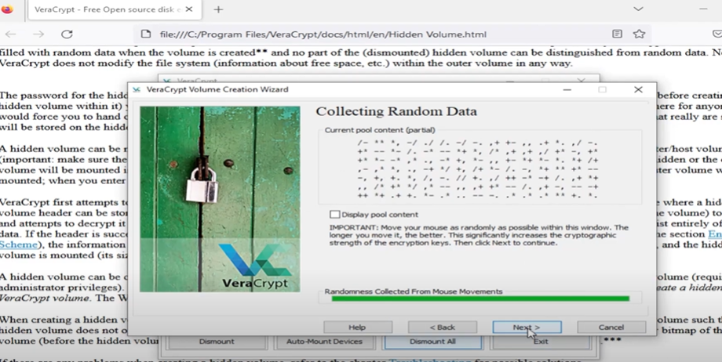

**Creating a Veracrypt rescue disk:**

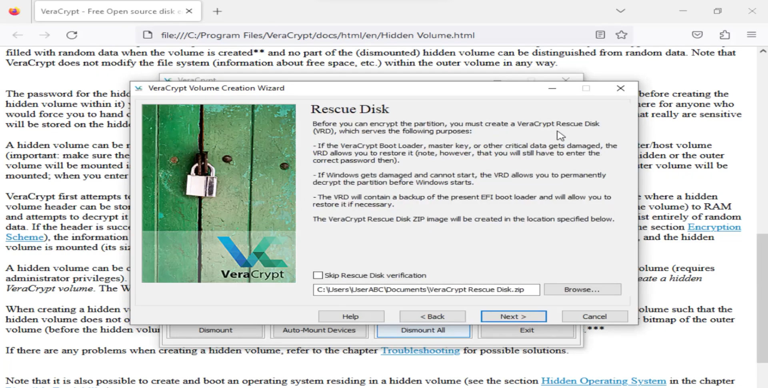

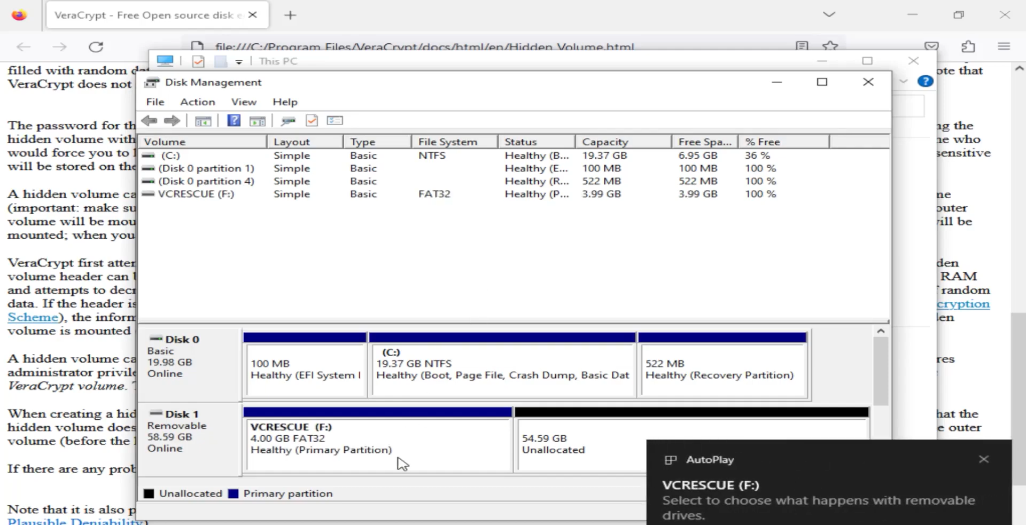

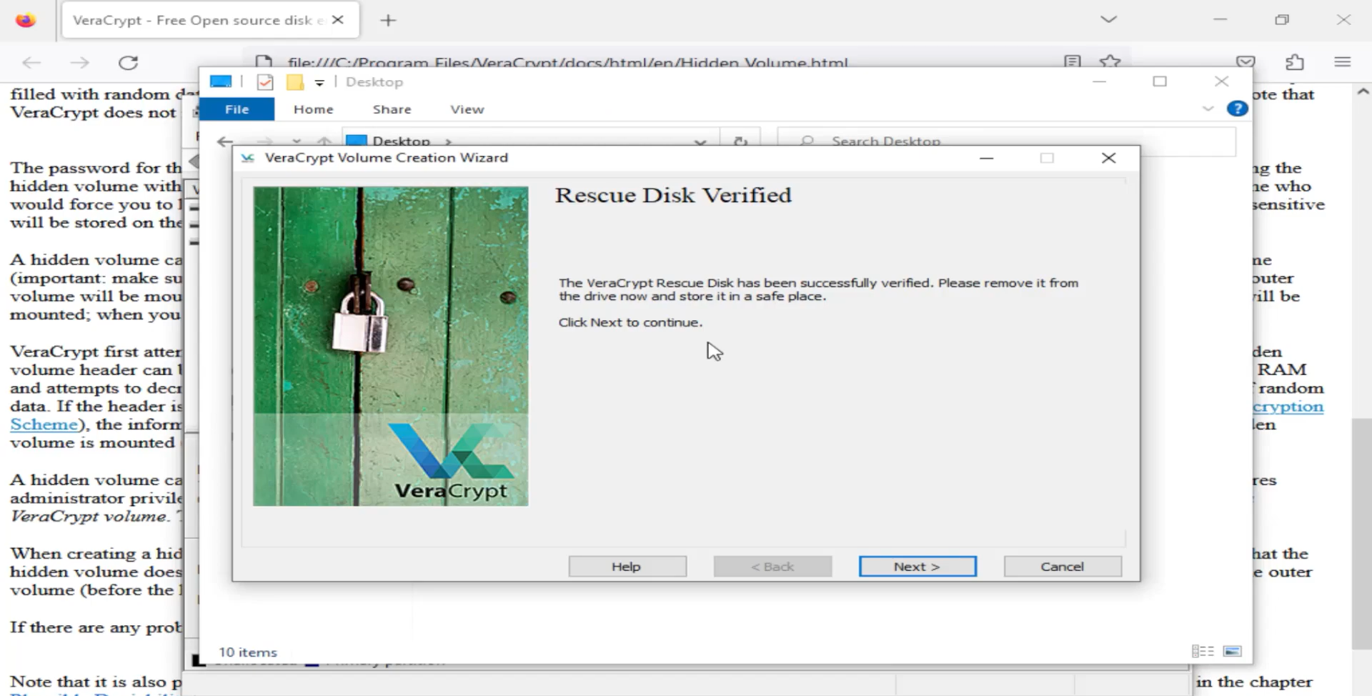

**System Encryption Pretest :**

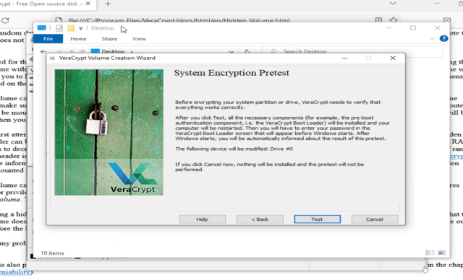

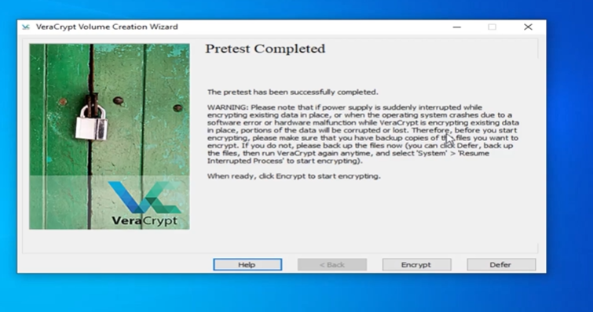

**Results:**

The results of the exploration indicate that Veracrypt is a robust and versatile encryption tool, offering comprehensive security features for protecting sensitive data. The creation of encrypted file containers, mounting of virtual drives, encryption of non-system partitions, and other functionalities performed reliably across different use cases.

**Conclusion:**

In conclusion, Veracrypt emerges as a powerful encryption solution suitable for securing data at rest and in transit. Its diverse range of features, including hidden volumes, system encryption, and plausible deniability, make it a valuable tool for individuals and organizations seeking to enhance their data security posture. However, users should ensure proper understanding of encryption best practices and regularly update the software to mitigate potential vulnerabilities.